FINAL PROJECT PART 4 MANUAL TEST PLAN

Super Mario

Test 1: Walking

Pressing the D button, Mario should walk right and have the walking animation which will cause a position change.

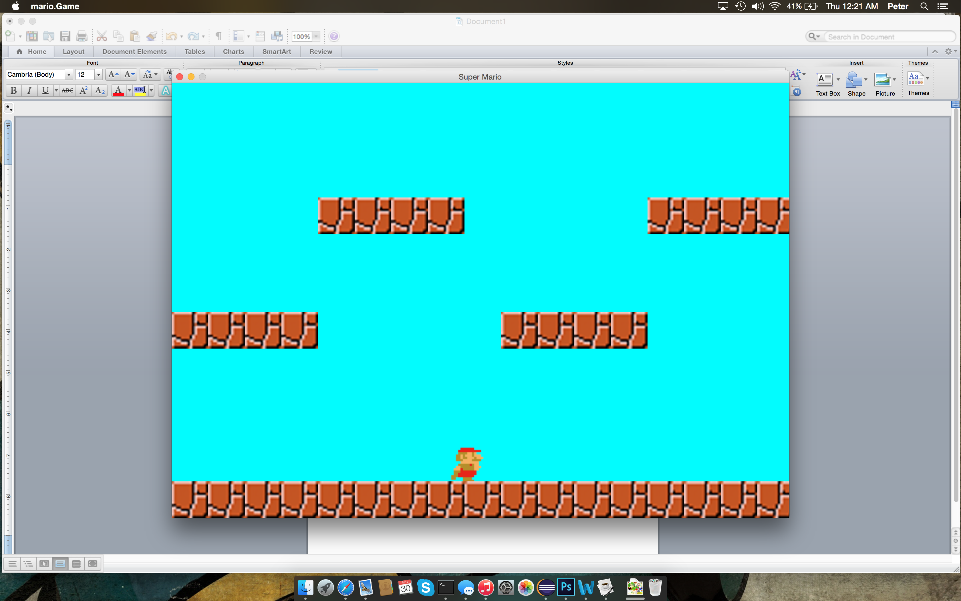

Pressing the A button, Mario should walk left and have the walking animation which will cause a position change.

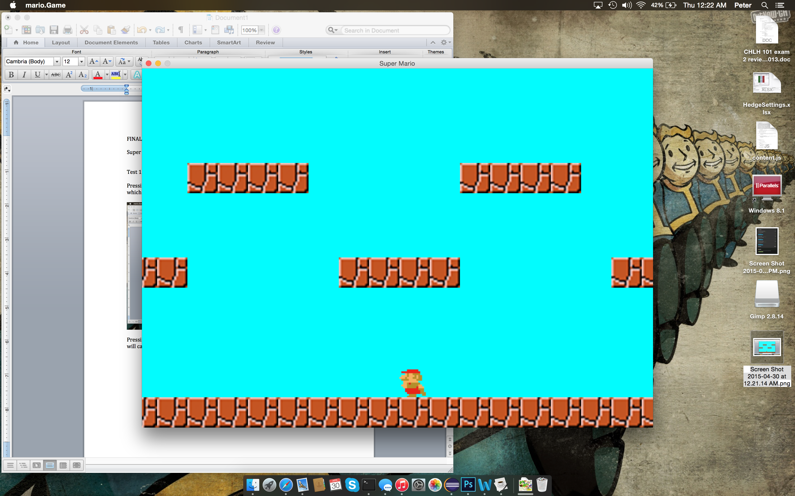

TEST 2: Staying in bounds

Mario should not be able to walk off of the left side of the level and the camera should not follow leaving the level in view.

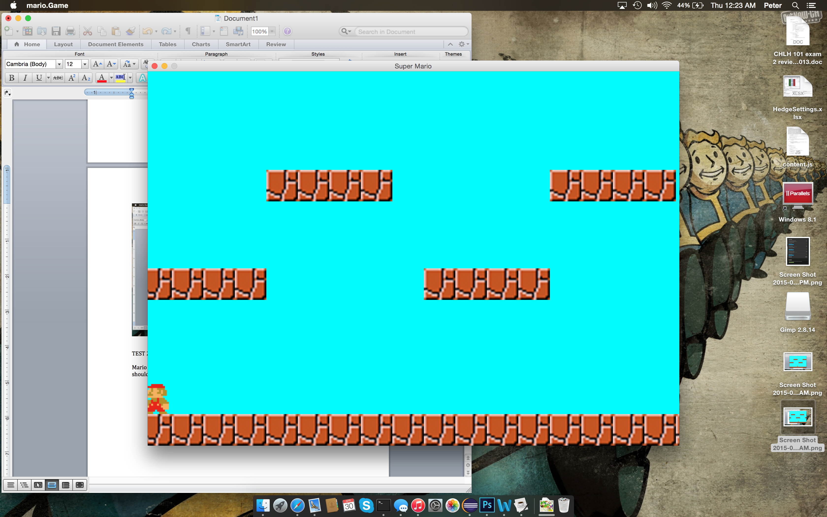

TEST 3: Jumping

Pressing the W button will cause Mario to jump and show a jumping animation.

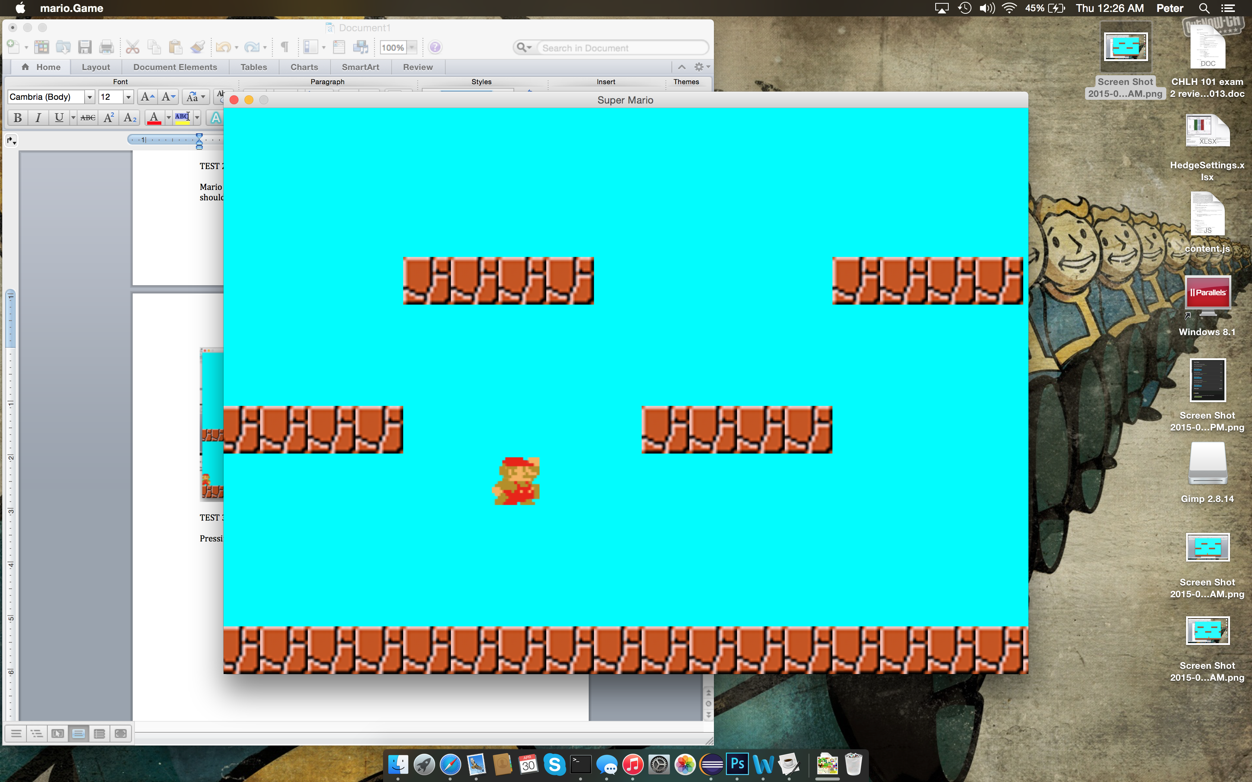

TEST 4: Jumping and colliding

When jumping Mario should stop and fall back down if he hits his head. 